

**MID TERM SUBMISSION**

**SUBJECT: CLOUD PERFORMANCE TUNING**

**SUBJECT CODE: CSEG3015**

**SUBMITTED TO: SUBMITTED BY:**

Dr Nitika Nigam Vilish Kumar  
Assistant Professor Sap Id: 500095673  
Data Science Cluster Roll: R2142211034  
School of Computer Science Batch: B- 6

**PROJECT: Deploying Websites on Different OS (Tourism Website)**

The tourism website with sections for information on upcoming events, tours, and destinations, as well as features for navigation, dark mode, and contact options. It also includes interactive elements and styling for a visually appealing user experience.

**OVERVIEW**

Our Project is all about Tuning the parameters of cloud computing and here we have using Microsoft Azure cloud provider for deploying our applications or websites on different Operating System By this we have figure out the various parameters such as CPU Utilization, Graph, Resource Time, Deployment Time and Memory Utilization and Performance.



**Major Difference Between AWS and Microsoft Azure**

Both Amazon Web Services (AWS) and Microsoft Azure are leading cloud service providers, and they offer various services and tools for cloud performance tuning. While the specific differences between them can change over time as they introduce new features and updates, here are some key points to consider when comparing AWS and Azure in terms of cloud performance tuning:

**1.Cost:** The choice between AWS and Microsoft Azure in terms of cost depends on your specific needs. Both cloud providers have competitive pricing, but the most cost-effective option for you will depend on the services you use, where you use them, and how you use them. It's like comparing prices at different stores – it depends on what you're buying and where you're buying it. To find the best fit, you'll need to analyze your usage, consider any long-term commitments, and keep an eye on data transfer costs according to me Azure is costly as here if use AMI’s the using cost is high here and give less memory for using in free tier as compare to AWS.

**2.Storage:** AWS and Microsoft Azure both offer robust storage solutions. AWS provides Amazon S3, EBS, and Glacier, while Azure offers Blob Storage and Azure Files. The choice depends on your specific storage needs and preferences. Consider factors like performance, scalability, and pricing to determine the best fit for your use case. Largest instance AWS offer 256 GB Ram + 16v CPU while Azure offers 224 GB + 16 vCPU’s.

**3.Availability Zone:** Availabilty Zone: Aws was the first on of its kind which means Aws is hosting in hosting in multiple locations worldwide and ofcourse it's true for Azure as well but differences occur’s in the numbers of regions and availability zones talking of numbers Aws has 55 availability zones worldwide with eight more on its weight whereas Azure is having 44 vailability zones with a whopping numbers.

**4.Services:** Aws and Azure both covers 100 plus services like compute, Database, Storage, Security, Networking and many more Some of the services that Aws covers(Ec2, AWS RDS S3, IAM,VPC, cloudwatch and cloud9 Similarly in Azure covers Vm, SQL, blob Storage, virtual network and Azure monitor and visual studio and many more.

**5. Open Source Integeration:** Aws has quite better relations with open source communities leading to more open integration with Aws which includes open source tools like Jenkins Docker, ansible, Github and its very friendly when it comes to linux servers while in Azure it offers native Integrations for windows development tools such as VBS,SQL and more as you all know Microsoft hasn’t always embraced this model but recently they have been catching with it and organization can run on RedHat and Hadoop clusters in azure.

**1.Deploying in Linux**

**Step1. First we Goto Microsoft Azure the create Vm’s and create a linux instance**

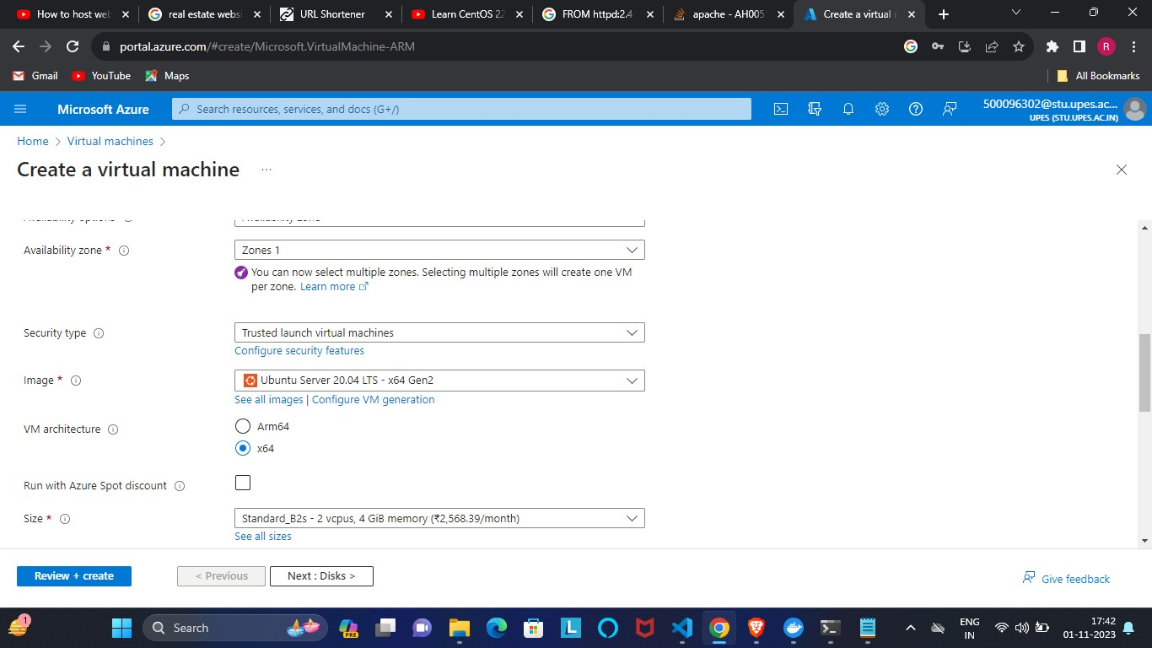

**Step2.** Here after creating Vm we adding some security rules.

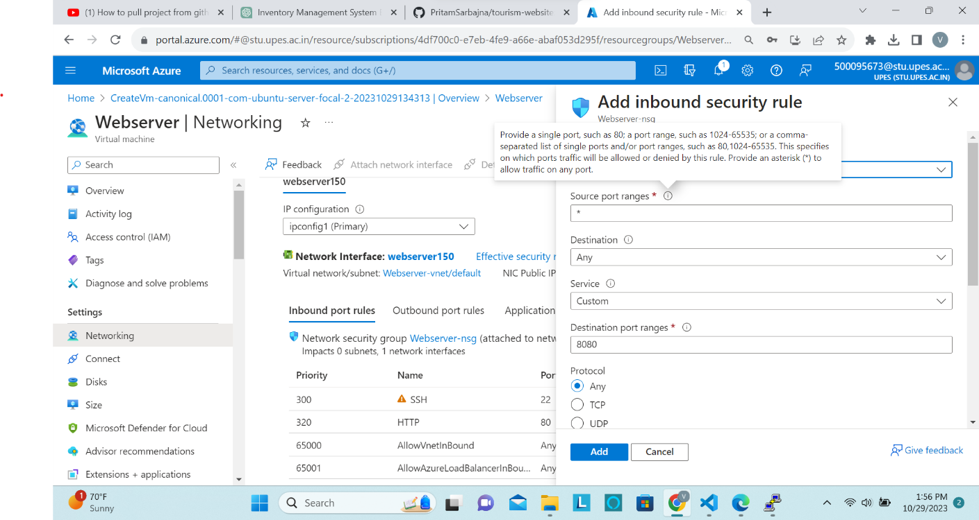

**Step3.** Now after successfully deploying Instance we just login in the instances.

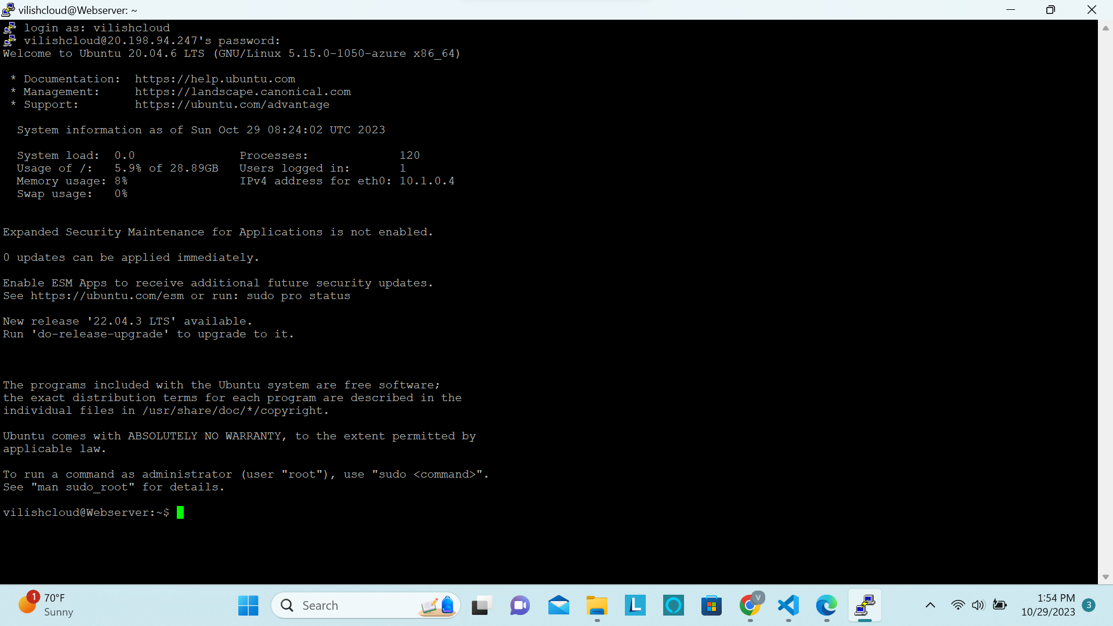

**Step4.** After that we check the port of our website what i want to deploy.

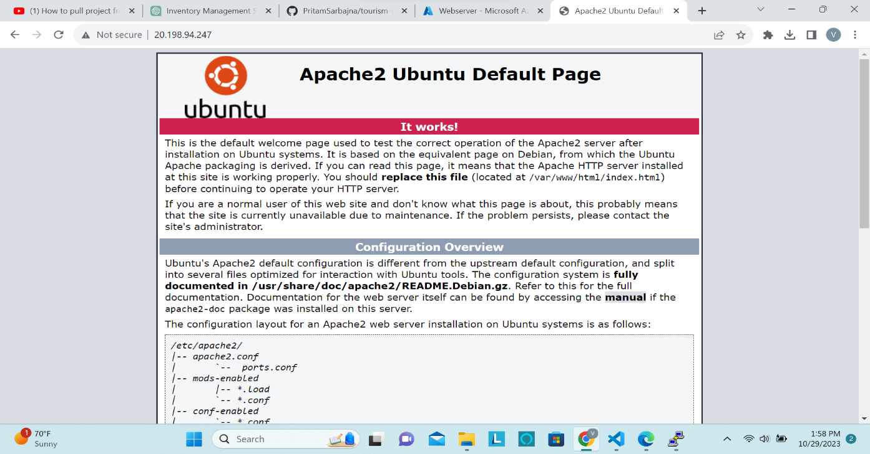

**Step5.** Sudo apt update (cto update the packages in linux)

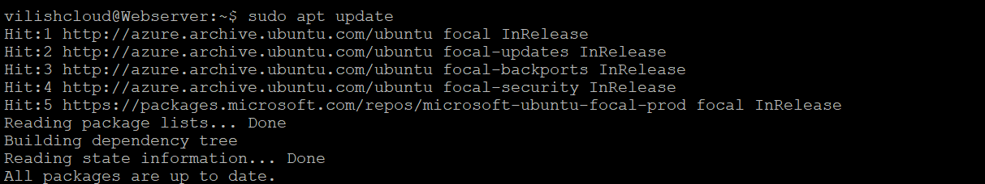

**Step6.** Sudo apt install -y apache2 (to install apache server).

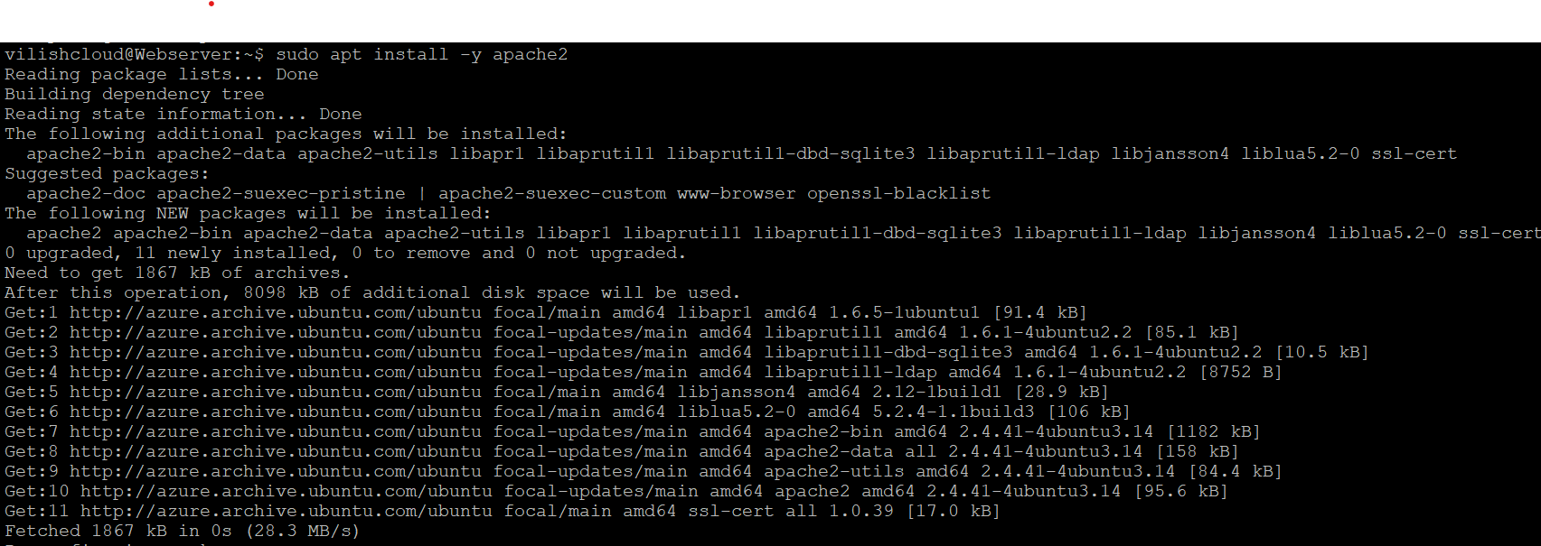

**Step7.**sudo systemctl status apache2 (to check the running server status).

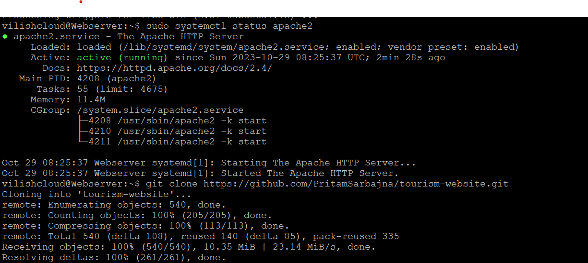

**Step8.** ls(to list the name features of file and directories).



**Step9.** Change directory in tourism website and restart apache server

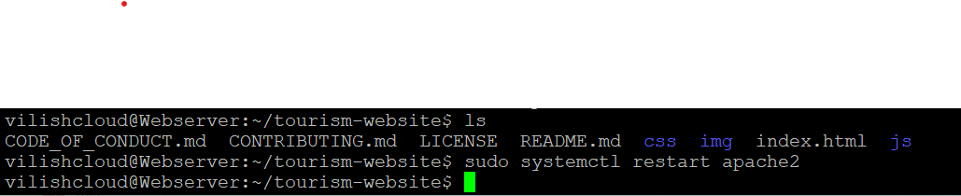

**Step10.** After starting the server, we refresh the port in browser and here is the output after successfully deploying the commands.



**Step11.** install nmon to check the performance.

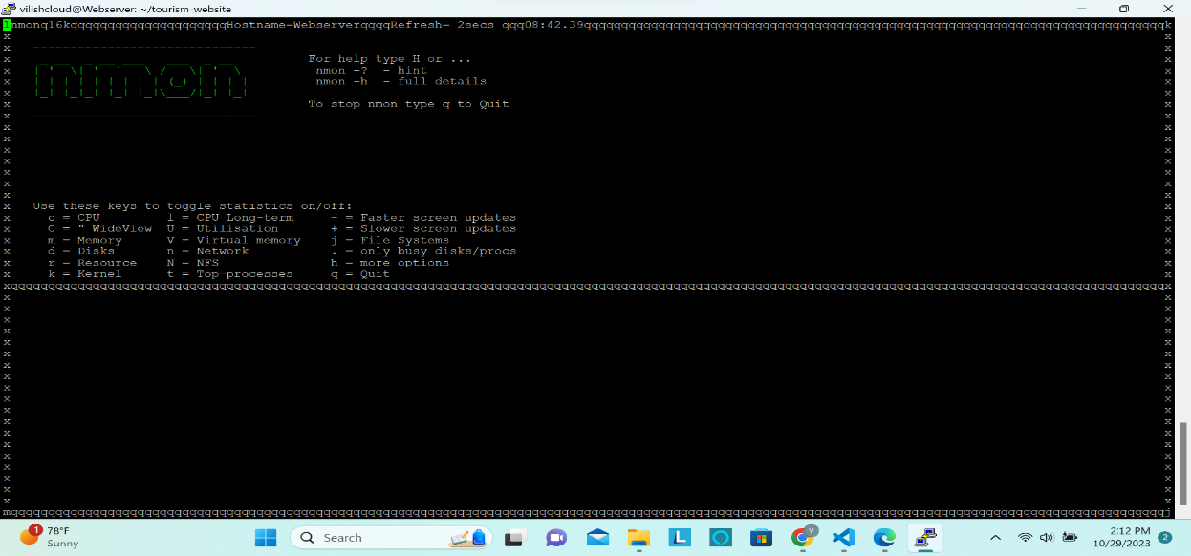

**Step12.** Resources during hosting website.

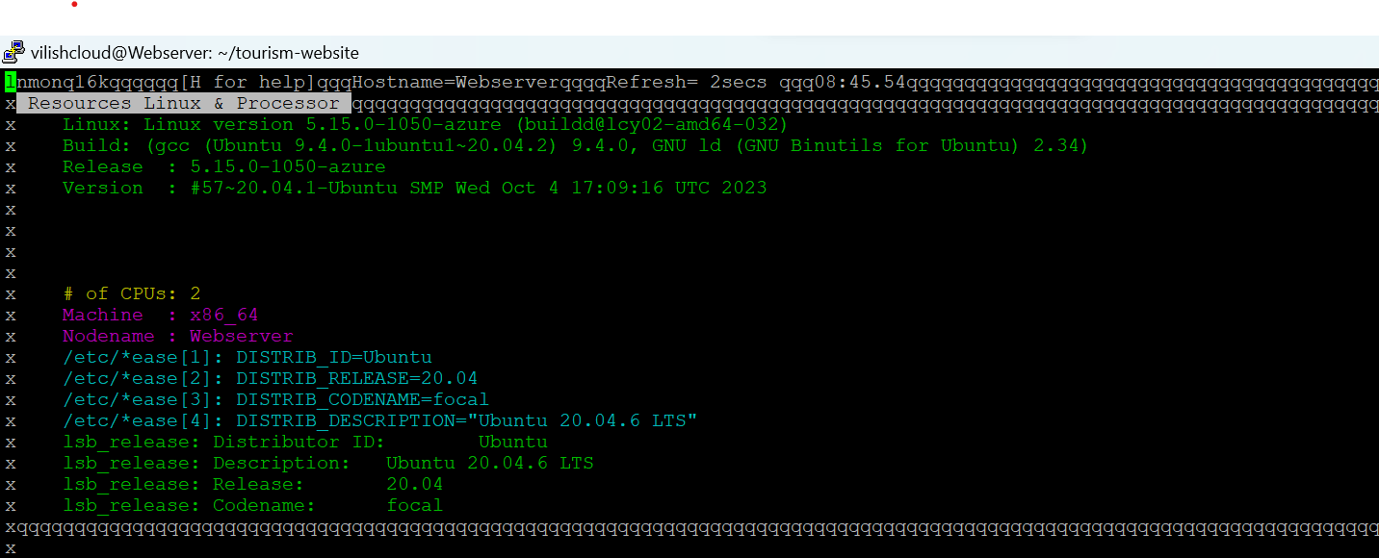

After closing the website:

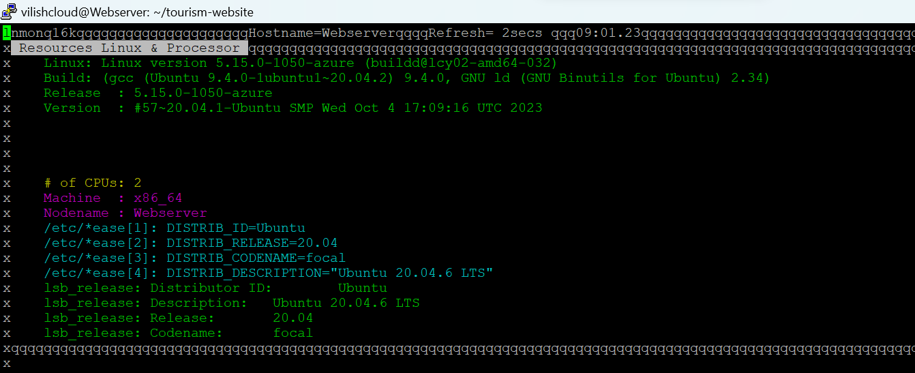

**Step13.** Memory during Hosting

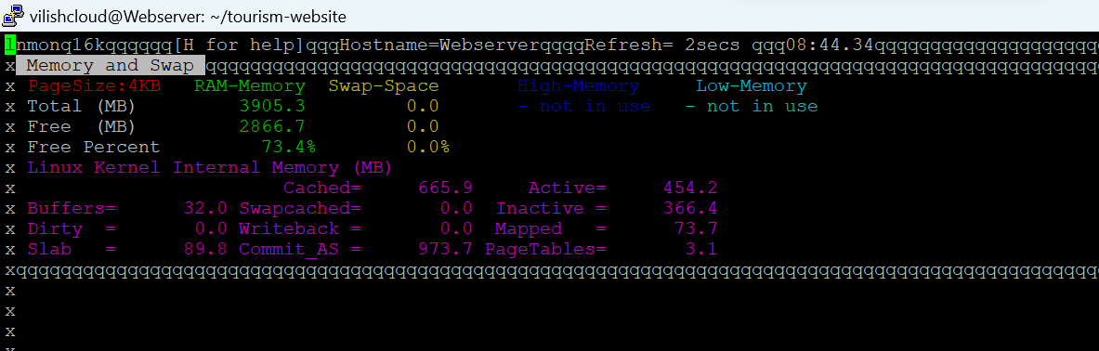

**After:**

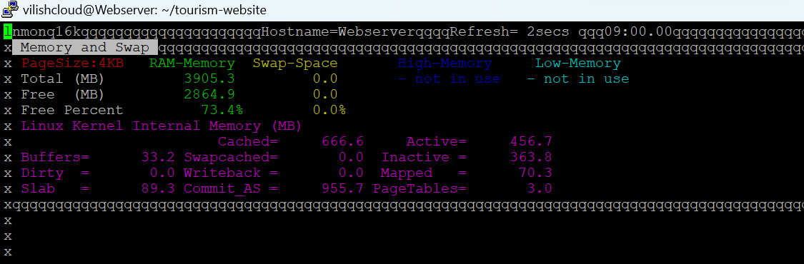

**Step14.** Utilization during hosting.

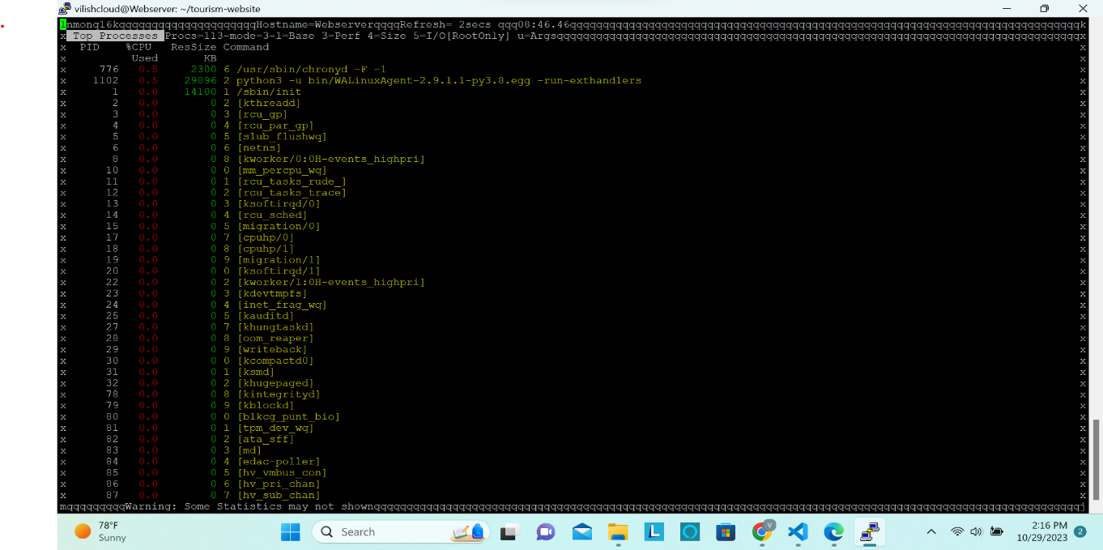

**After:**

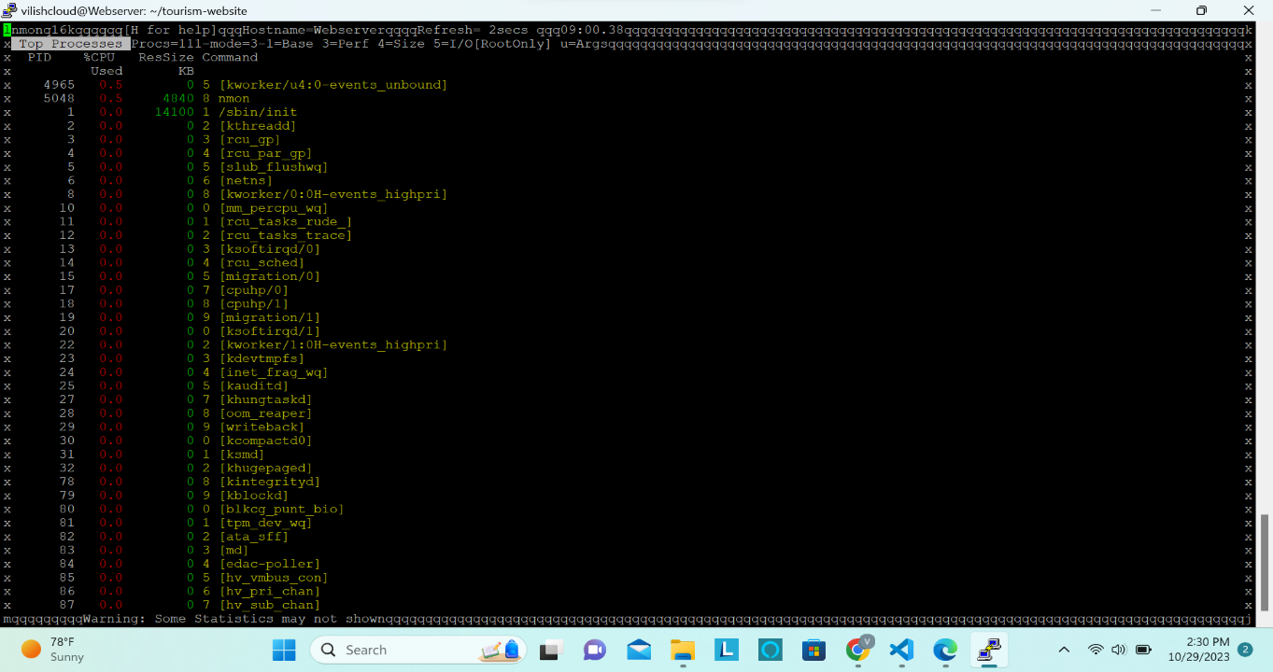

**Step15.** CPU utilization

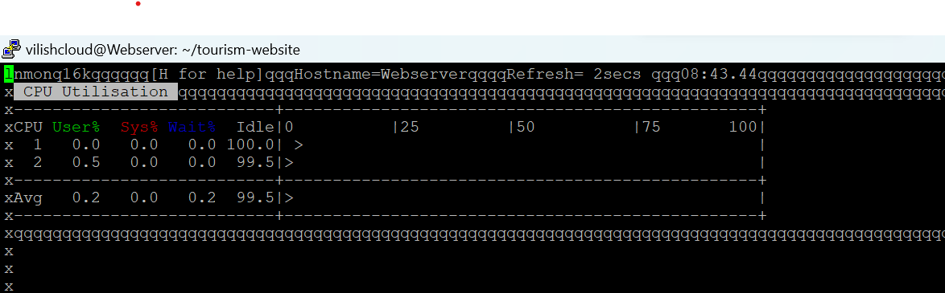

**Step16.** Memory utilization using htop.

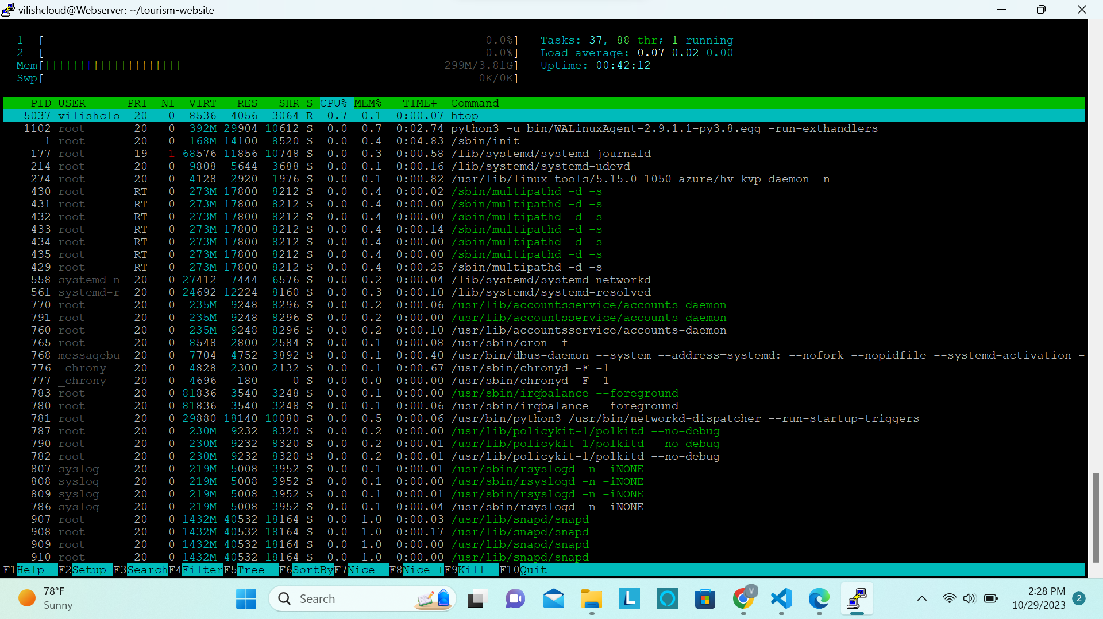

**Total Response time taken in Linux = 10min 20 secs**

**2. Deploying website on windows**

**Step1.** Open Azure and create vm instance of window.

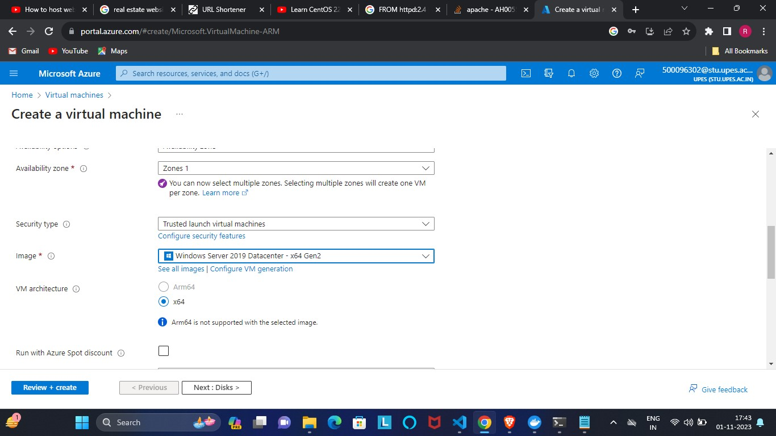

**Step2.** Copy files from base OS to vm.

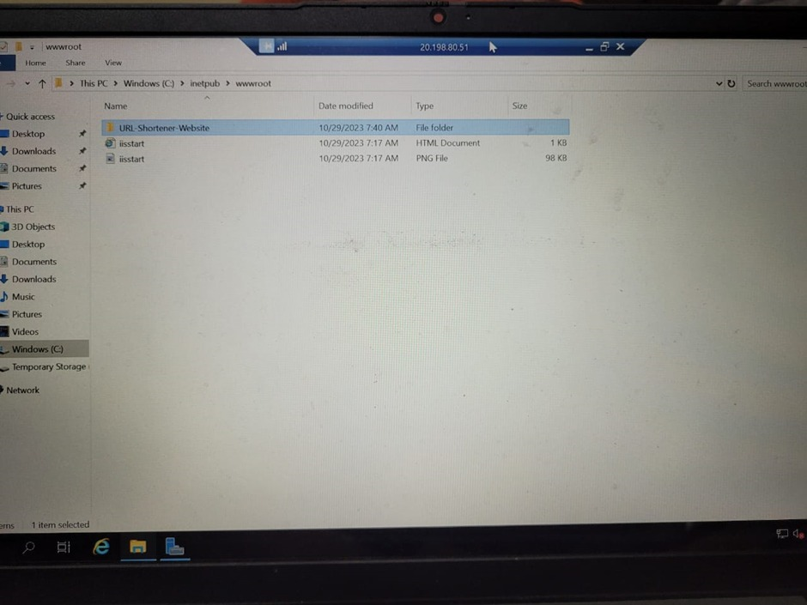

**Step3**. In IIS manager inside (Device Manager) we adding the website and give the name & port number of our website.

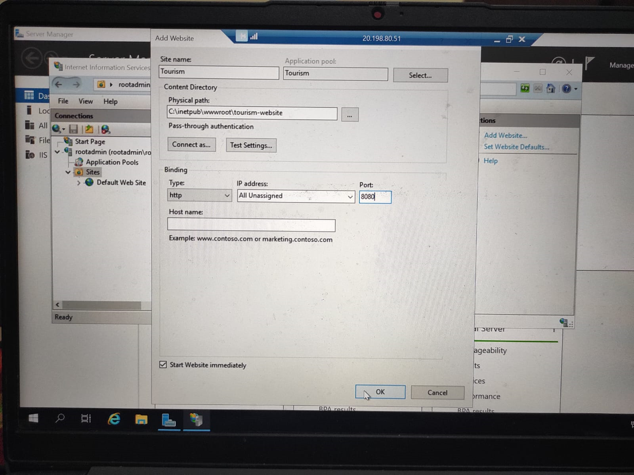

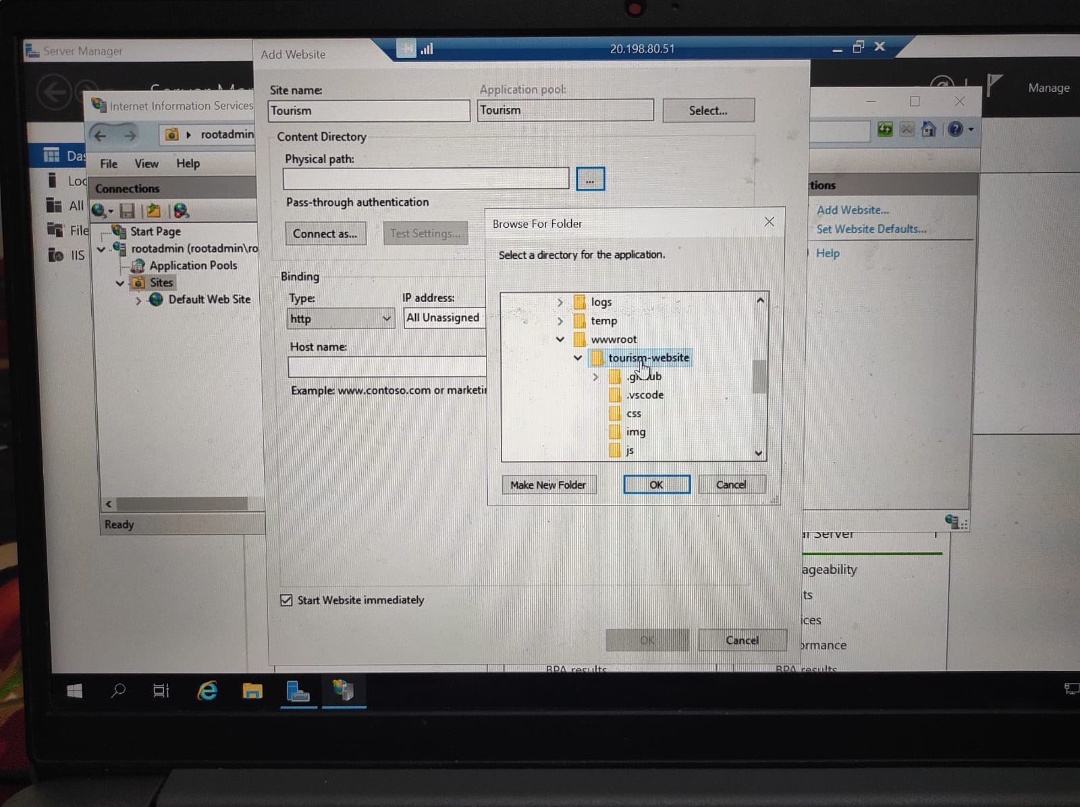

**Step4**. Then we go to manage the website and select browsing to open the website.

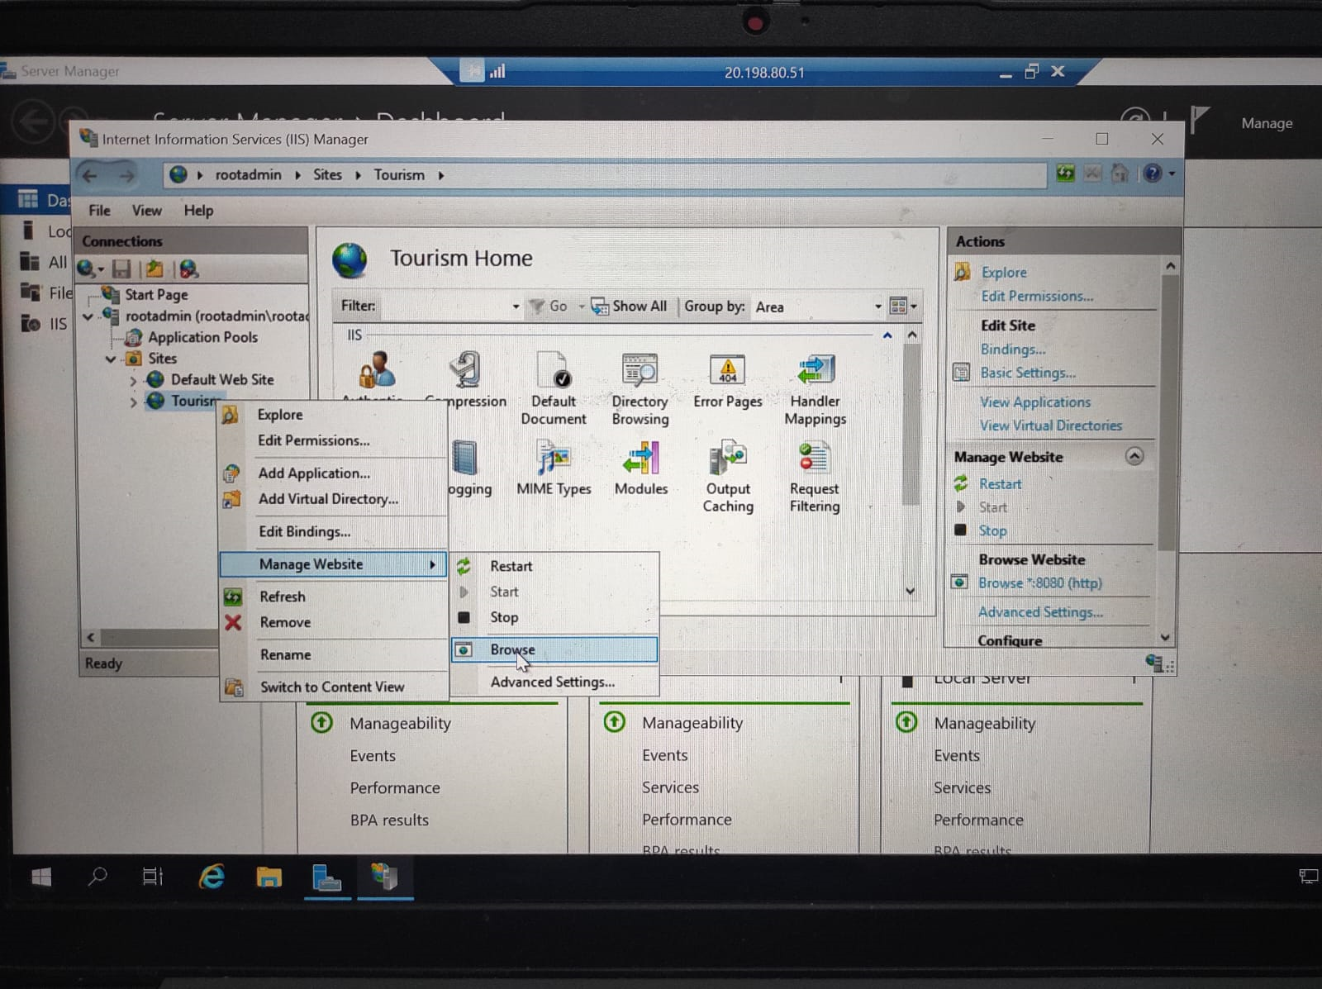

**Step5**. Now you can see our website successfully deployed.







**Step6.** To check the performance we open task manager



To check processes:

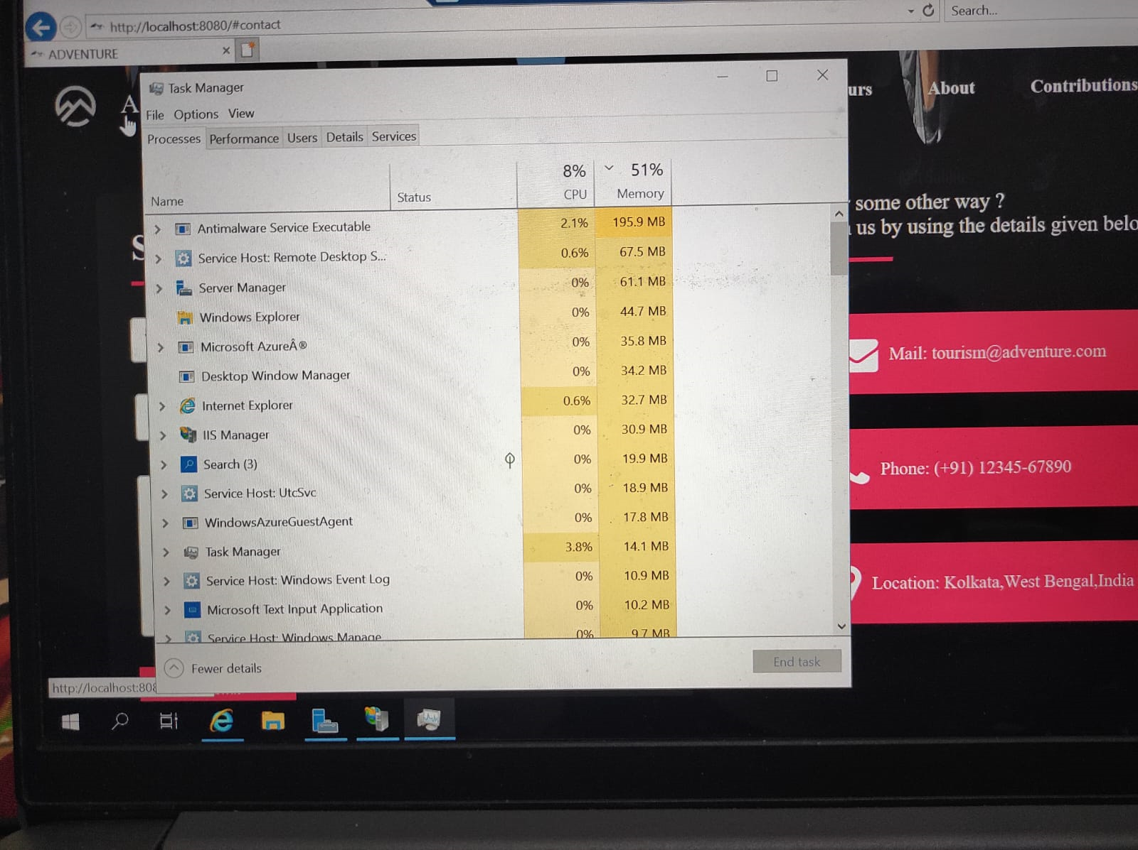

To check the memory utilization: during hosting website

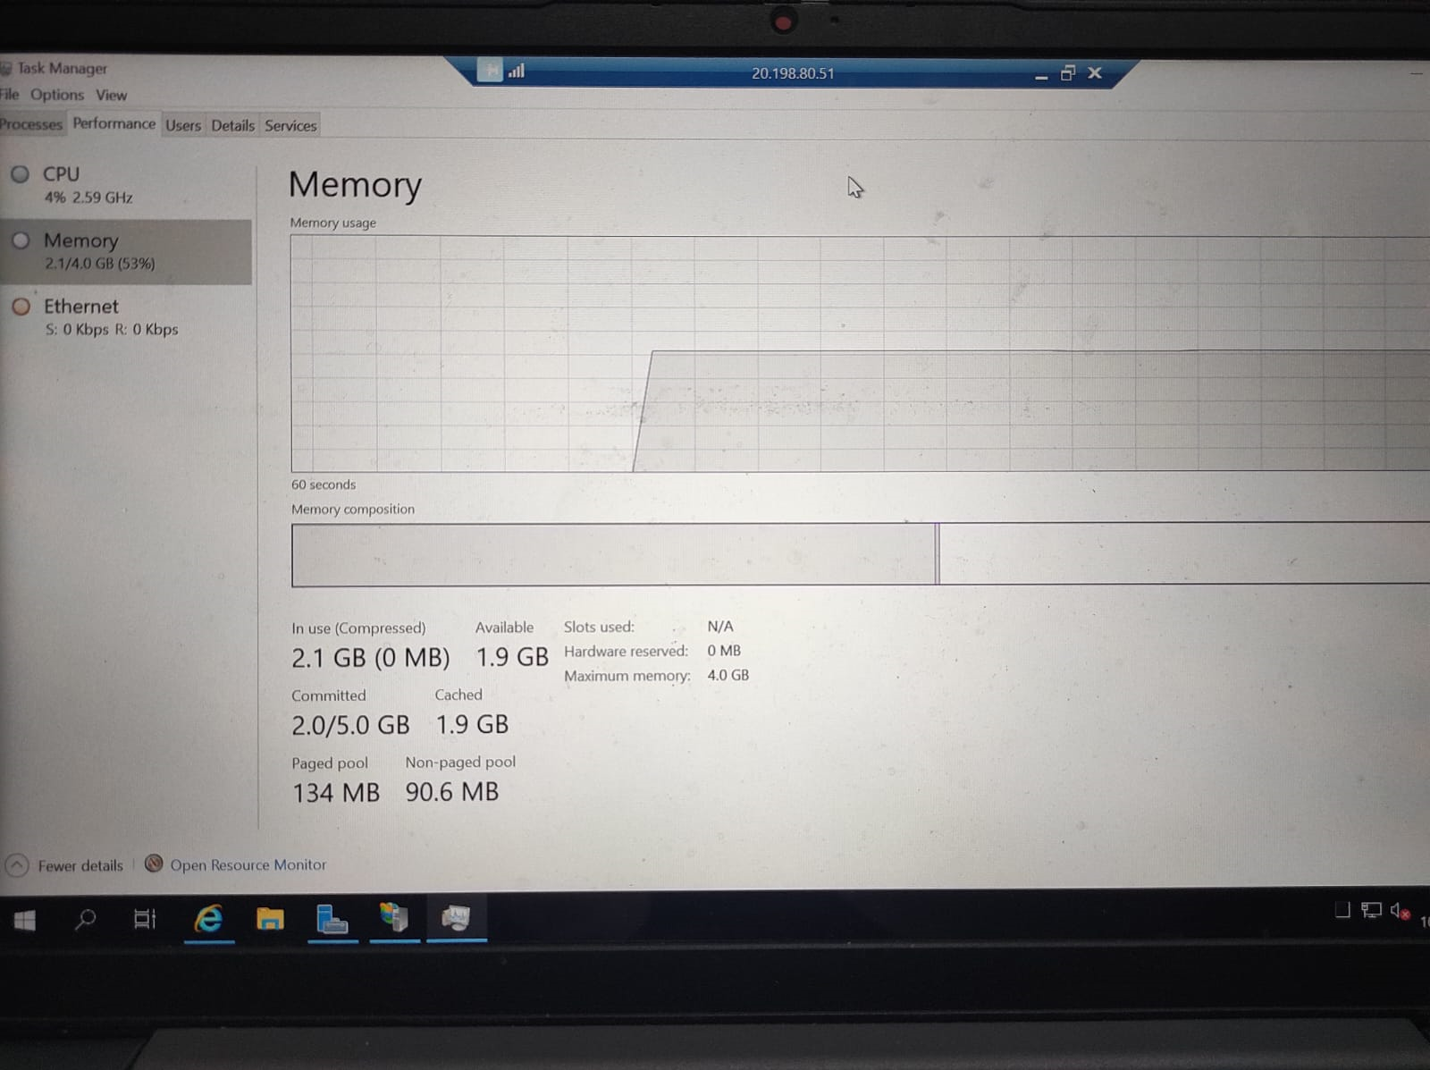

After closing website:

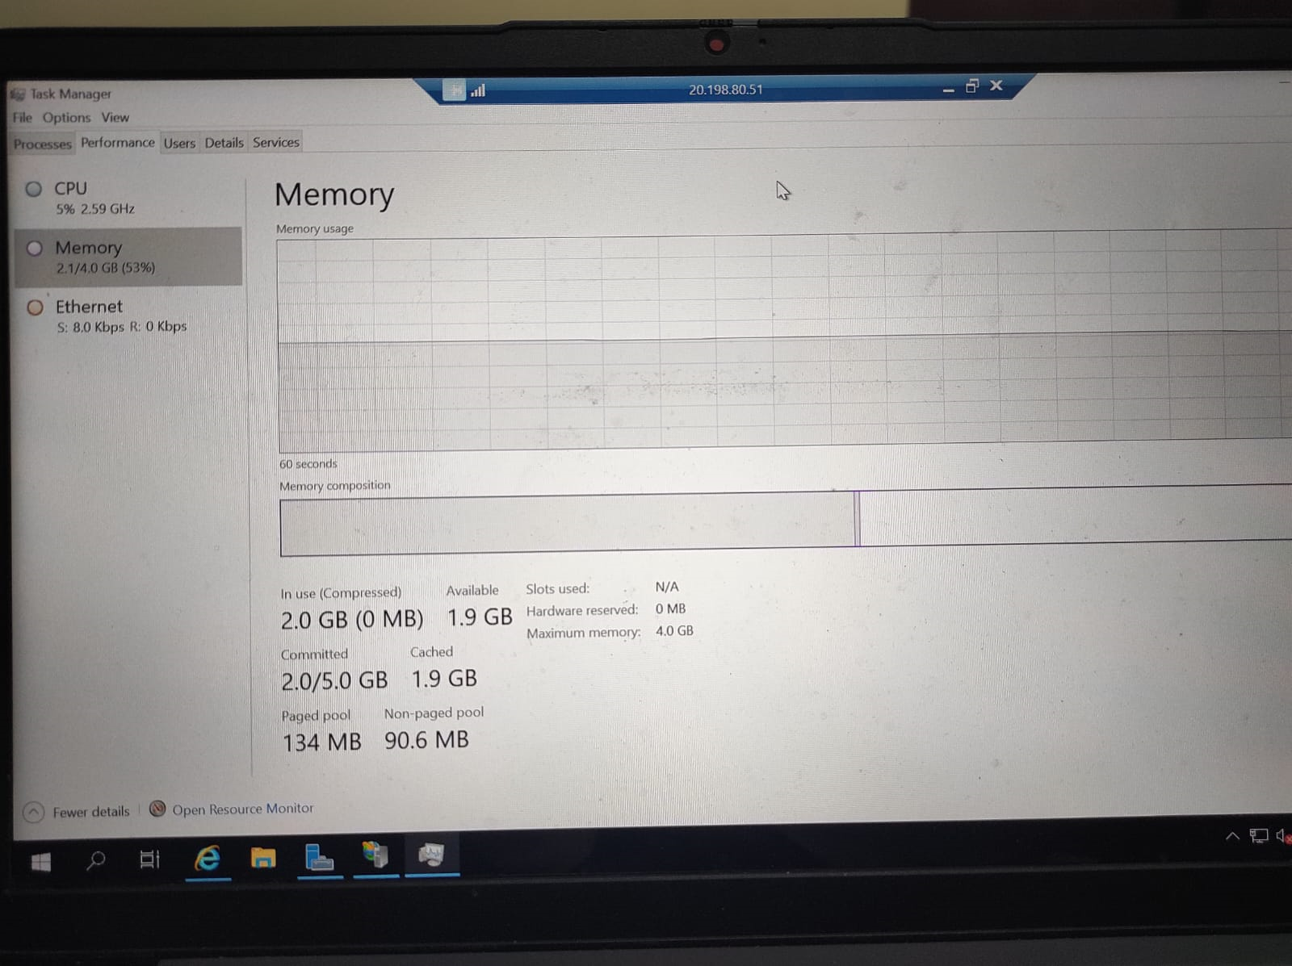

To check the cpu utilization: during hosting website

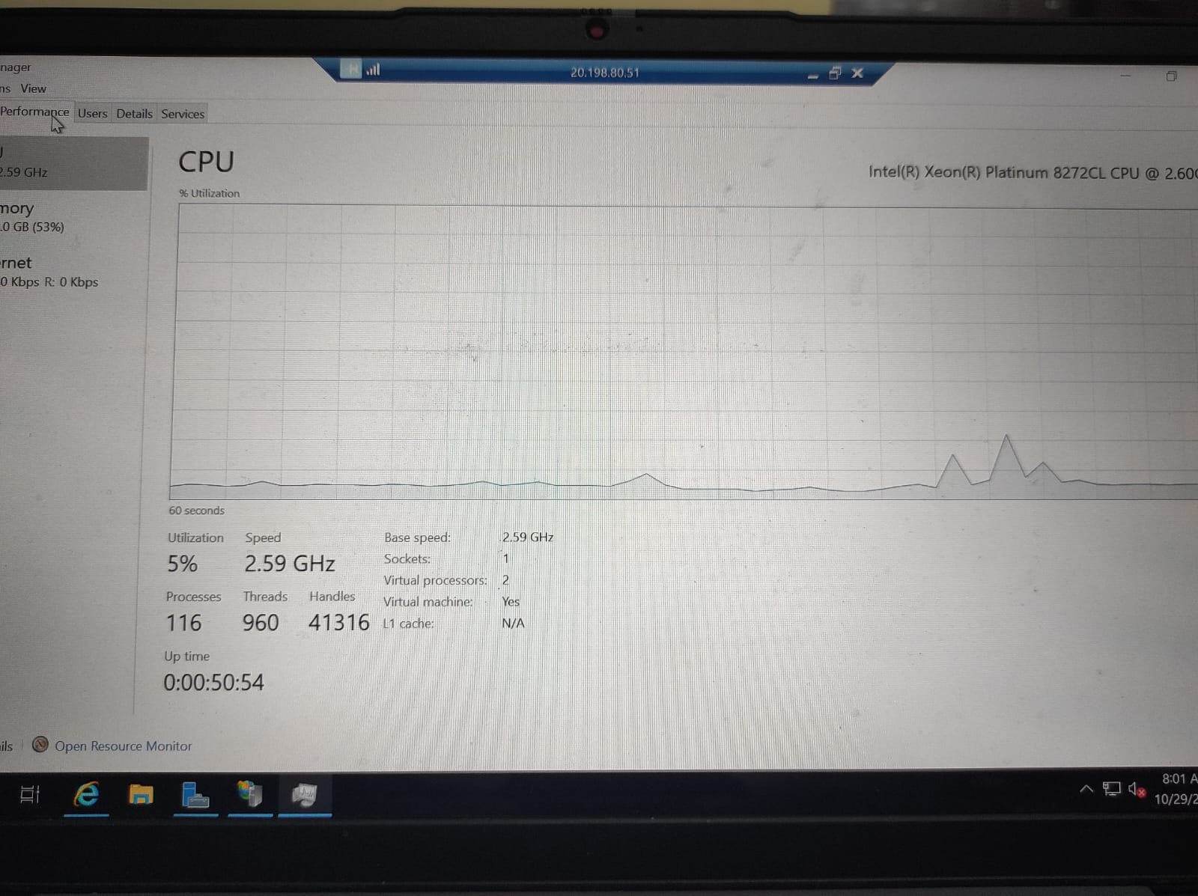

After closing:

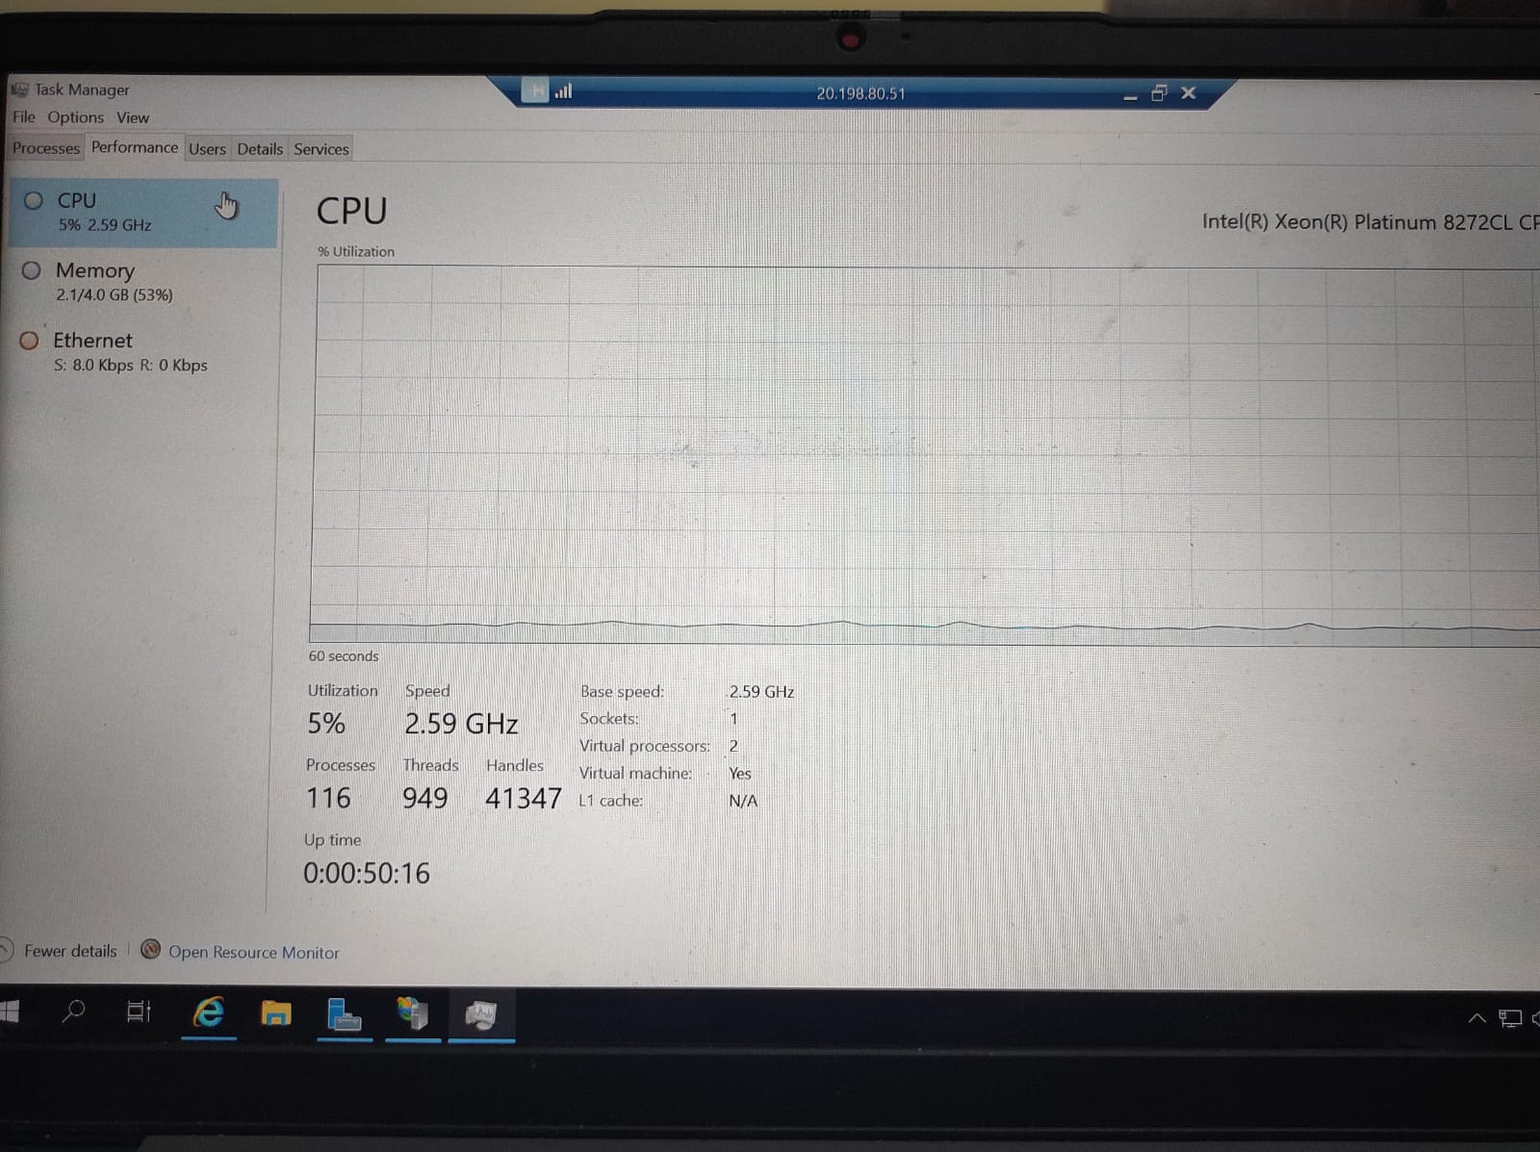

To check the graph during hosting website our graph is like given below:



After closing website:

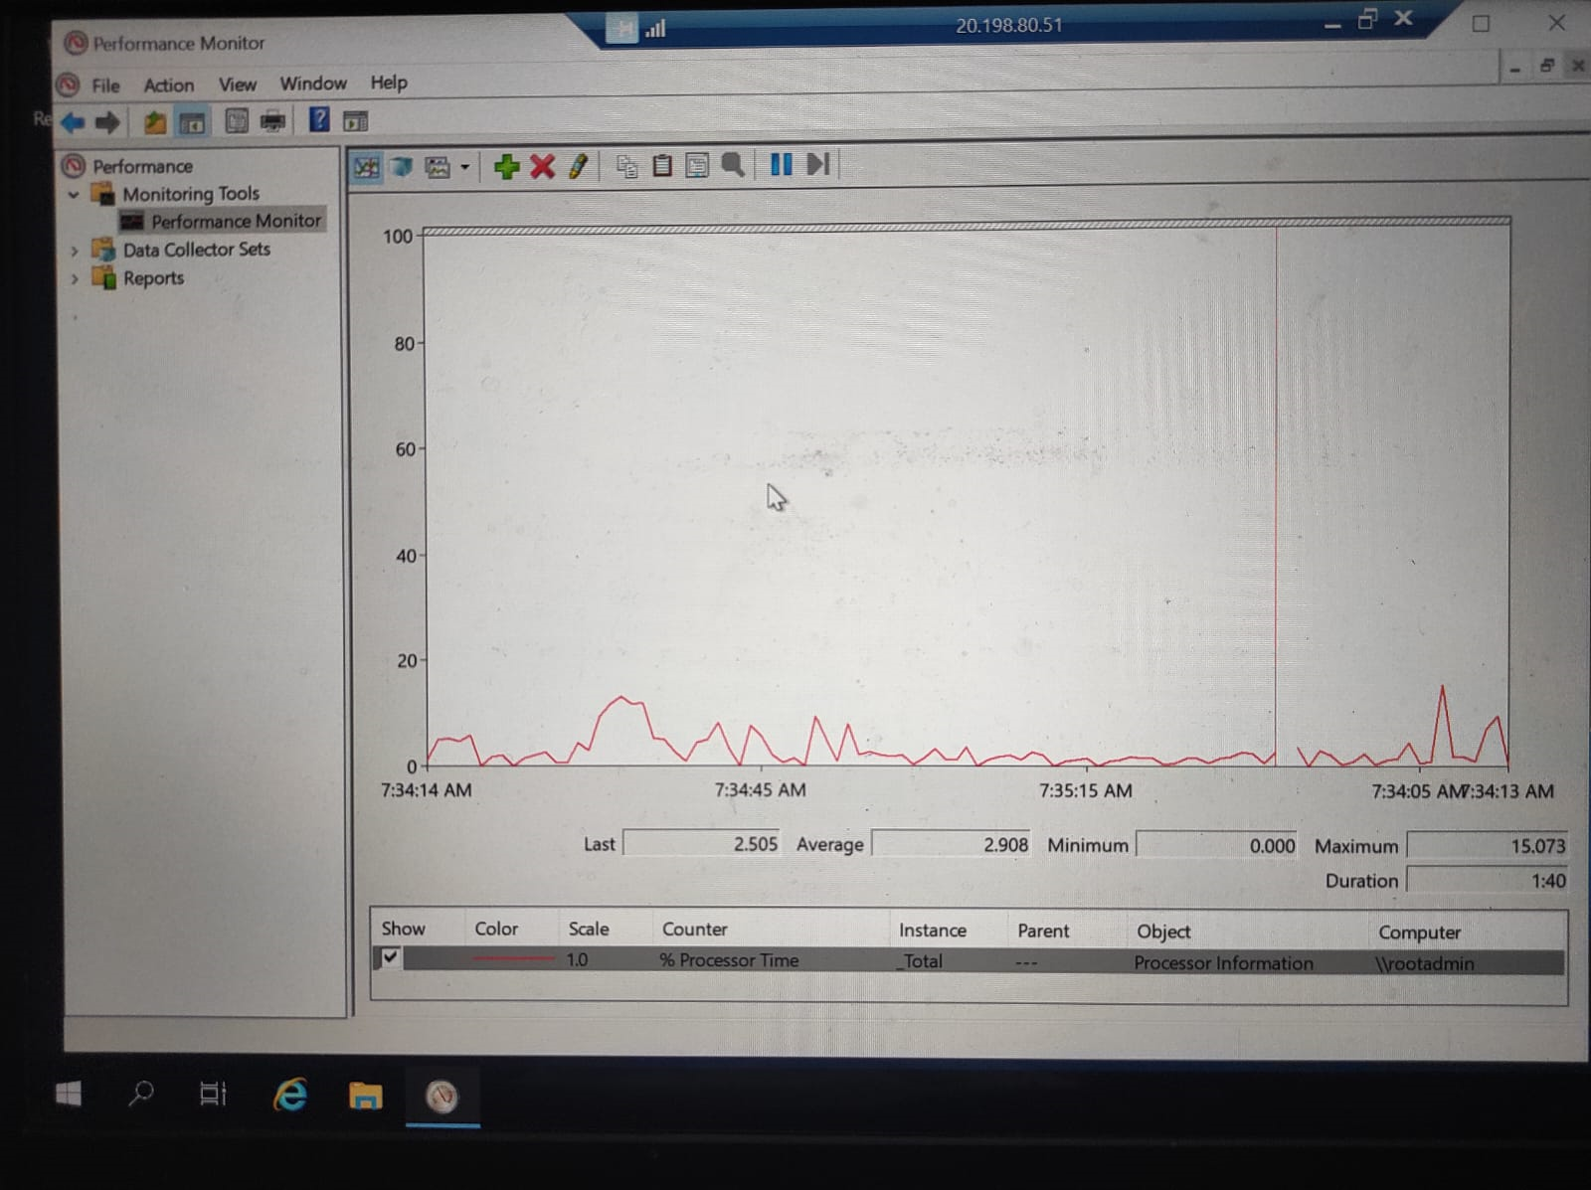

**Total Response time take for deploying: 13 min**

**Conclusion:**

**CPU Utilization:**

We have seen in this case, Ubuntu VM tend to have lower CPU utilization compared to Windows VM , Ubuntu is known for its lightweight nature and efficient use of system resources, making it an excellent choice for resource-conscious applications.

**Memory Utilization:**

Also, Ubuntu VM had lower memory utilization of less than 300M compared to Windows VM, Ubuntu's minimalistic design and efficient use of RAM contribute to this advantage. This can lead to cost savings and better performance in situations with limited available memory.

**Response Time:**

Response time of ubuntu: 10 minutes and 20 seconds

Response time of windows: 13 minutes.

**Fast OS:**

In terms of response time, a fast operating system, and overall performance and resource utilization, Linux generally has the edge over Windows. Linux is known for its efficiency, stability, and lower resource requirements, making it a popular choice for servers and high-performance computing as it takes less deployment time so we can say it is better than window Os.